**DG W2 Notes**

Notes:

Principles, in this industry, are tools that can be used to effectively design a game. Principles can be used unintentionally, so the more aware of what you’re using, the better you can study and more effectively use them in future.

One core idea of game design is this: game design begins with concepts (ideas and goals of the final project) that then influence mechanics (the actual materials and processes created for a project), and the mechanics in turn can influence the concepts back.

Feedback loops are often used to encourage or discourage player behaviors or reactions to in-game features. These can range in scope from simple, primary mechanics like jumping in a platformer, to whole story-driven campaigns that change depending on players’ actions. A feedback loop, if desired, should be made to be as strong as possible.

Flow refers to the state in which a player’s mind has reached peak immersion and proceeds to play until something causes an imbalance in the ‘flow channel’, or pacing of the game. A flow channel could be maintained, for example, by adapting the difficulty of the game to a speed matching the progression of the player’s skill level, as well as having periods of varying difficulty where players can ‘stabilise’.

Flow graphs show the relationship between a game’s difficulty and a player’s emotions during gameplay.

Important are the thesis, antithesis, and synthesis of a game (AKA the goal, the conflict, and the result). The goal is what the player wants to or has to accomplish. The conflict is what stops the player from completing the goal. And the result is essentially what happens when the player interacts with the conflict.

Agency involves what’s at the control of the player versus what’s controlled by the game. This can include how much the gameplay is done through player-controlled strategy or computer-generated luck. Agency is balanced in different ways to influence the experience of different games.

Environmental storytelling is using clever level design to deliver a mental message or instruction to players.

The ‘golden path’ is the default path a player through which a player is expected to experience a game, at least in the context of a new, uninformed player on their first run.

Iteration is when the same game mechanic or action is used several times (usually by players) but in different contexts.

Gestalt or ‘the whole being greater than the sum of its parts’ can apply to the way a game is designed. It’s the experience that occurs when all the individual concepts, mechanics, and other components are used at once to form a game.

Gestalt has several smaller principles that cover how you could psychologically view the individual contents of a project –

Closure/reification: Seeing material as a whole, even when not all intended components are present.

Continuance:

Similarity:

Proximity:

Symmetry:

Invariance:

Figure ground:

Game pillars are core features that SUPPORT the entire game, such as jumping in Super Mario Bros. They are crucial to more or less the entire experience.

The 80/20 rule is the supposition that, on average, 80 percent of a game will be experienced by using only 20 percent of the features (i.e. walking and jumping are used far more often than enchanting in Minecraft). This prioritises the amount of development time given to different features in regards to how significant each one is.

Note: Simplify these notes later into a dictionary. The PowerPoint I got these from will be on BlackBoard by the end of today.

Game Design Documents:

Unique Selling Product (USP): Content needed to distinguish the game from similar titles and find buyers among the target demographic.

When writing about the resources used in a game design document, instead of stuffing them into the document, make a spreadsheet (i.e. using HacknPlan) and write the list of assets, tools, scripts and programs etc. used there before attaching it to the document.

There are example templates of game design documents in the page for assessment 5 on Blackboard:

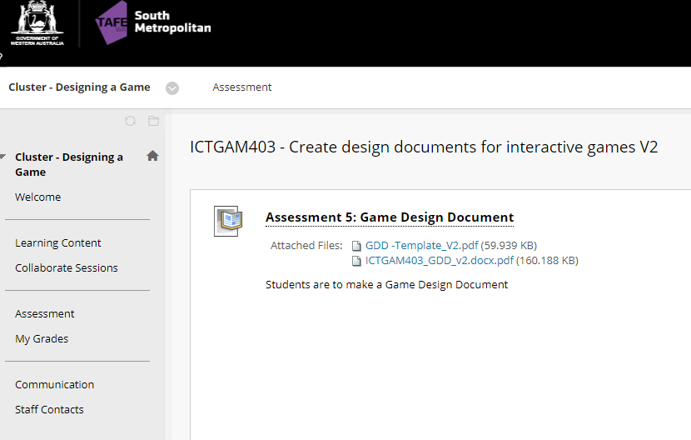

Use ‘screenshots’ on the title page of the document. Story and progression will be discussed next week. Wherever possible, I should use spreadsheets, tables and graphs.

Need to check the other examples – Narbacular drop (precursor to Portal) and Race’n’Chase (precursor to Grand Theft Auto), for the kind of content and features to mention (i.e. story flowcharts). Even just looking at their tables of contents would be tremendously helpful.

Not assessed on artistic concepts. They just need to convey the basic functions of the game, not be incredibly detailed concept art. Particle and bit counts are recommended once the asset list is complete.

There will be a real 5-minute presentation done in class.

Parts of the portfolio (which is due at the end of week 7):

Genre + Target study due end of week 5. Gaming Timeline due end of week 6. Serious + Non-Digital due end of week 7. Design Document due end of week 7.

Assessment 2 (game design document) is assumed to be due end of week 7 or 8.

My account comes with an Adobe Creative Cloud subscription. There’s a program in that called XP or something which can be used to make spreadsheets?